

DEVOPS FOR CLOUD COMPUTING
Assignment

Name:
Tehreem Mirza

Registeration No:
FA22-BSE-088

Section:
BSE-8B

Submitted To:
Sir Muhammad Ibrahim

Tasks:
We need to perform the required tasks on two machines using Ansible.
Ansible will be installed on only one machine, and from that machine, we will manage both systems.
We have to run both of yesterday’s tasks in a single playbook.
The playbook should do the following on both machines:
• Display the CV
• Create the required users
So basically, one Ansible playbook will be used to complete all tasks on both machines.

- Using Ansible to automate tasks on multiple machines (Local + AWS)

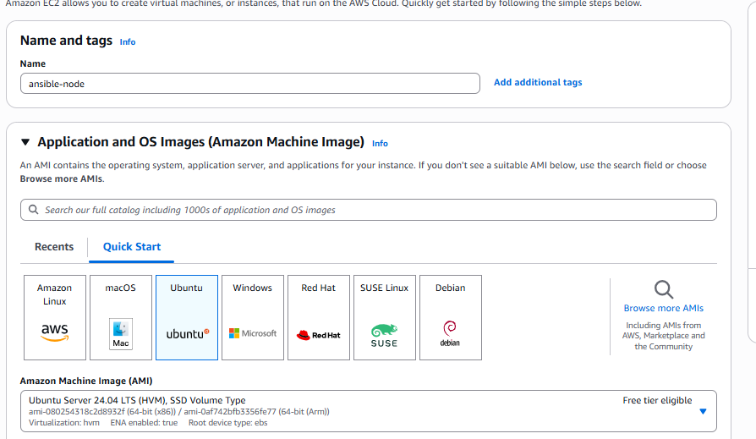
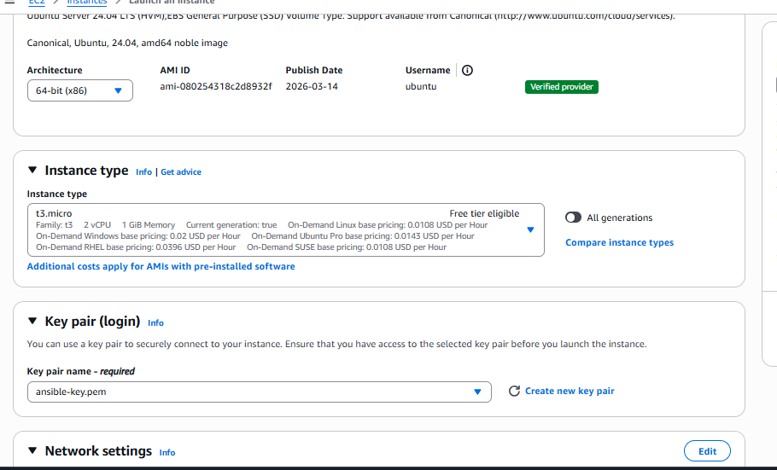

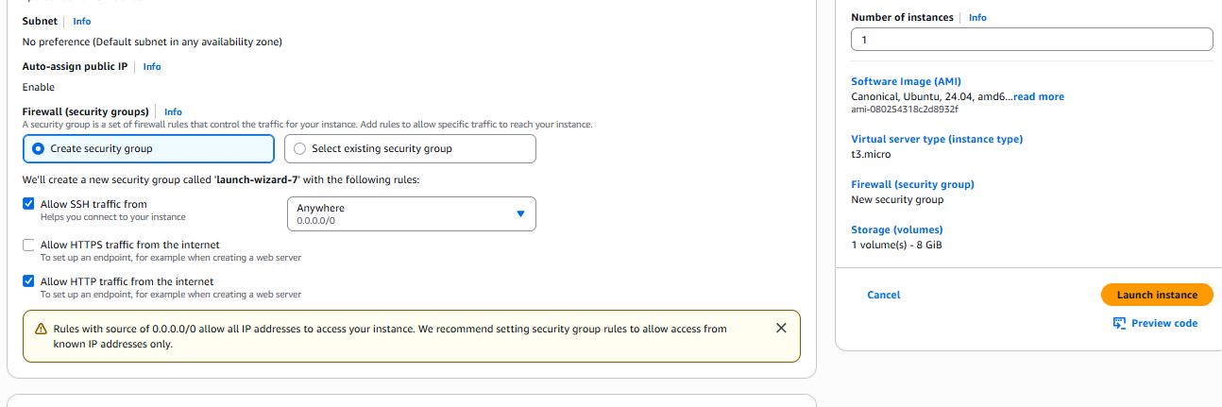

Instance is created:

Local Machine (WSL)
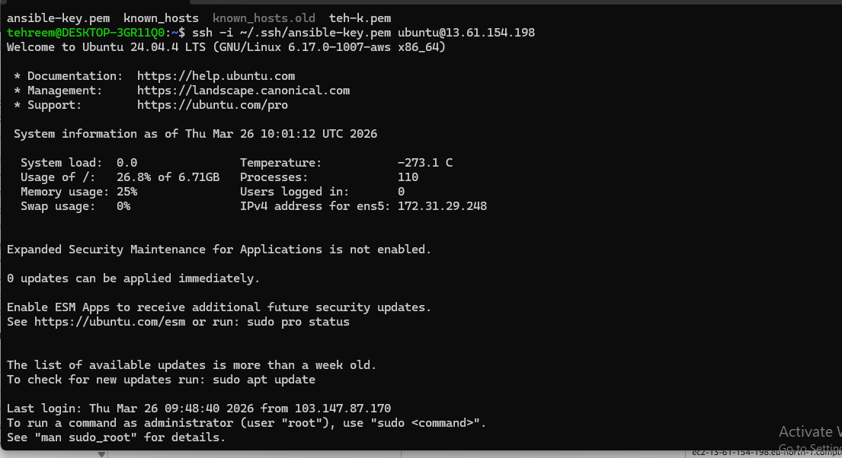

AWS machine ready
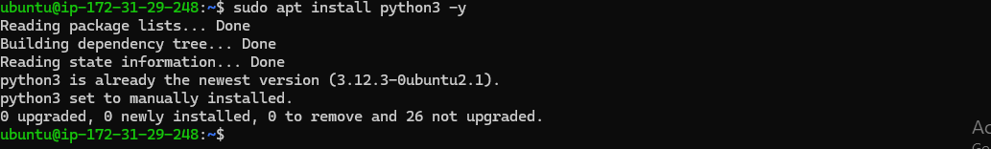

Inventory file update
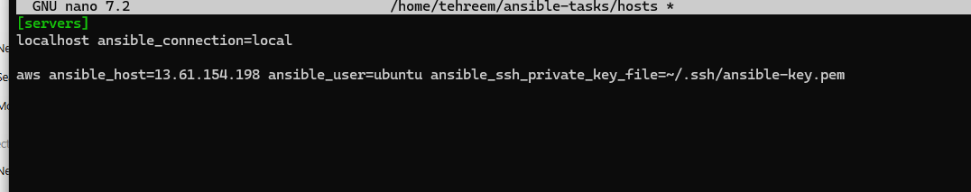

Inventory file update
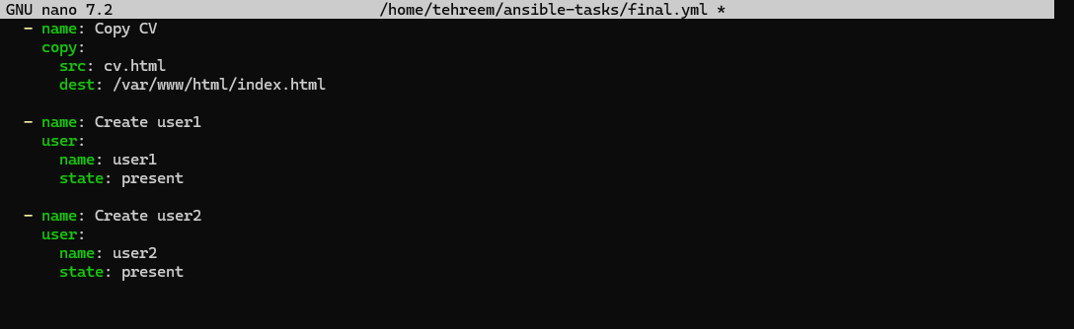

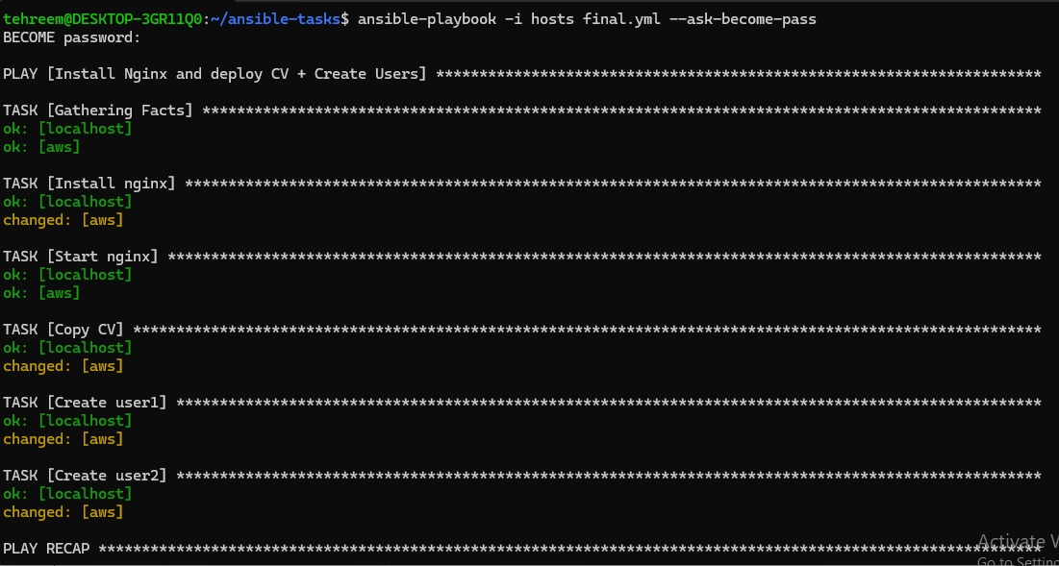
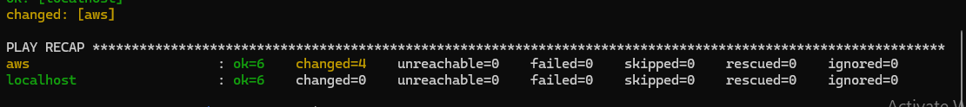

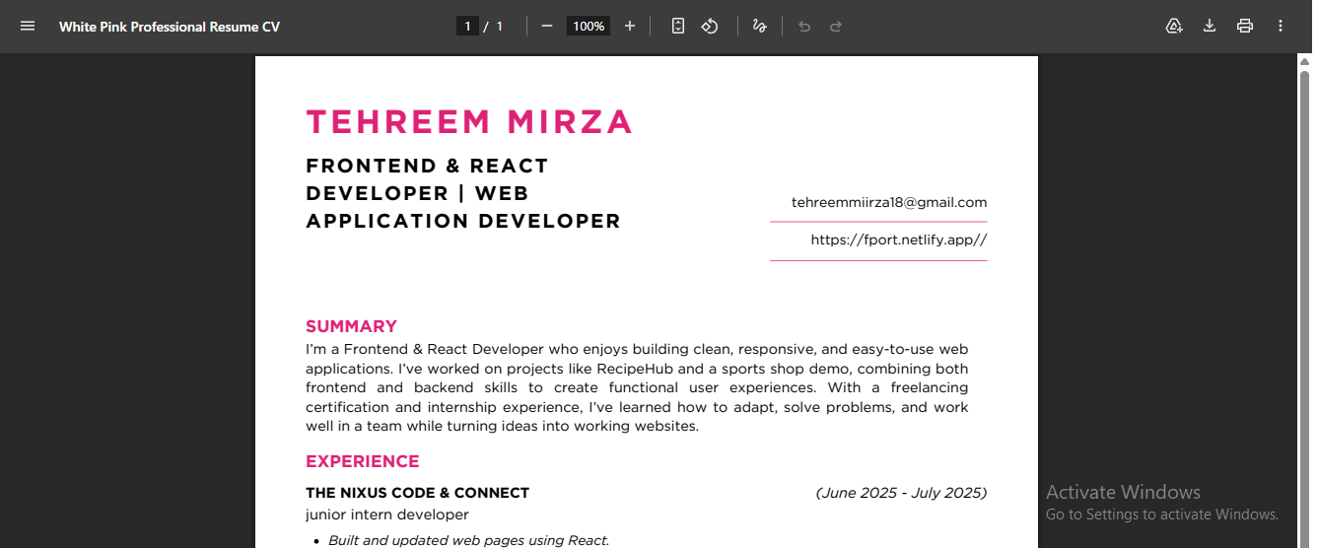

Users check


